**Hay Camera Club**

**New Member Welcome Pack**

|  |  |
| --- | --- |
| **Membership Number:** |  |

**Message from the Club’s chairman**

Welcome to Hay Camera Club.

I hope you find this Welcome Pack helpful. It briefly identifies some of the information you may need to be familiar with and is intended to give you an effective start as a new member of the club.

This pack is designed both to introduce you to the Club and to be of continuing use during your membership.

I ask that you study carefully the contents, particularly the rules and regulations concerning club competitions. If you require any clarification or additional information please let me or another member of the committee know and we will be happy to help.

General amendments to the pack will be issued from time to time, usually after a formal discussion and agreement with club members. These updates will usually become available from our website or via our weekly emails.

The Club was founded in the 1940s, with the aim of improving the photographic art and technique of its members. New members and visitors to Hay Camera Club consistently say that the two things that impress them are the friendliness of the organisation and the enthusiasm of our members. I hope this will be your experience as well.

If there is anything that I or another committee member can do to help you settle into the club, do not hesitate to let one of us know.

Hay Camera Club would like to wish you every success as a new member; whether you have joined as a social member or with the aim to exhibit and participate in the various competitions and trips that take place throughout the year. Whatever your level of involvement, I hope your experience will be positive and rewarding.

Good luck with all you do and I hope you have a great time in Hay Camera Club.

|  |  |
| --- | --- |
| **Peter Seaman** | **Club Chairman** |
| Contact telephone Number: | 01874 676225 |
|  | |
| **Your contact for general membership enquiries is:** | |
| **TBC** | **To be emailed separately on joining** |
| Contact telephone Number: | To be emailed separately on joining |

**What we do**

* At our regular weekly meetings we exchange ideas and advice on everything photographic from cameras and lenses to composition and editing.
* We also have around four in-house competitions a year, as well as about four external "battles", when we invite an independent judge to comment on our work and, most importantly, to encourage us.
* We enjoy regular workshops and presentations by visiting professional and amateur speakers and also by our own members, who are able to share their diverse skills and experiences with other members.
* During the summer months we frequently organise practical photo shoots and trips to interesting locations.
* We are affiliated to the Welsh Photographic Federation and have links with other local clubs in the Welsh Marches, and even to one as far afield as New Zealand!
* The membership includes photographers with all levels of ability from the very experienced to the complete novice and is wholly representative of the local community with whom we have close links.
* We are a very friendly and sociable group and also organise regular social events such as our annual Christmas meal and quiz night.
* Please visit the Club’s website to obtain details of our weekly programme.

**When and where we meet**

**When**

* Our Club meetings are normally held every **Tuesday** evening between **7:30pm** and **9:30pm**.
* We normally take a break from meetings in July and August, but may take the opportunity to arrange practical sessions and outings instead if the weather permits.

**Where**

* We meet normally in **Hay** **Masonic Hall**, Brecon Road (B4350), Hay on Wye, **HR3 5DY,** which can be located as follows:
* Leaving the centre of Hay heading west on the B4350 and passing the Swan Hotel (on the right-hand side), the road curves to the right. The Masonic Hall is some 200 yards further on, set back on the right.

Or

* If you are travelling from Glasbury along the B4350, as you begin to approach Hay and pass the Fire Station (on the right hand side). The Masonic Hall is some 200 yards further on, set back on the left.
* There is a free car park almost opposite the Masonic Hall, adjacent to the tennis courts and Hay Bowls Club.

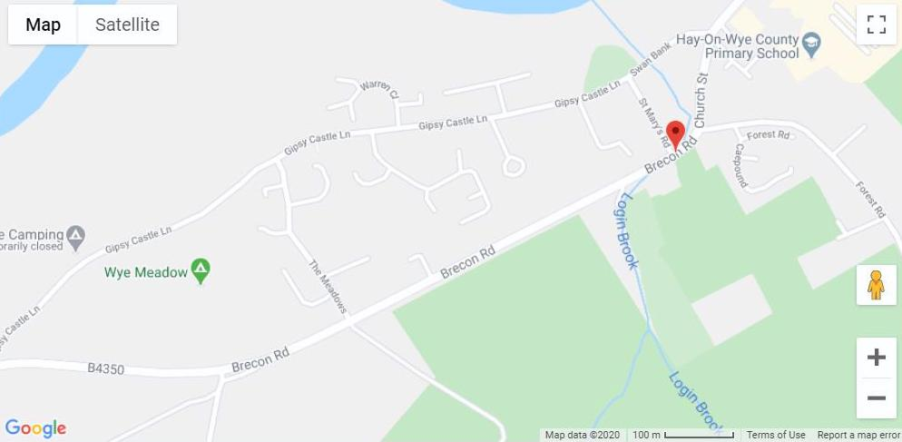

**Competition Rules**

**1. Organisation**

1. Competitions are held during the Club’s season at the committee’s discretion, the first being an Open Competition held in January.
2. All competitions for both PDIs and prints can be Colour or Monochrome, or both, or as specified for individual competitions.
3. The Competition Secretary is to keep a record of the author, picture title and points awarded for all entries and is to announce the winner and runner up in each section at the end of judging.

**2. Rules**

1. Only fully paid-up members may enter Club competitions.
2. Each member may submit up to five entries unless otherwise instructed. Entries are to be marked with the picture title, the author’s membership number and numbered in priority (number 1 being the entry the member considers to be their best entry for the competition) so that the Competitions Secretary can reduce the overall number of entries to a competition if the number is too high. This applies to both print and PDI competitions. Members belonging to more than one club involved in the same "battle" can submit entries for any club.
3. Images entered must be entirely the work of the photographer. Composite images are permitted, provided all component images meet this requirement.
4. No photograph previously entered into an internal Club competition, and a winner, may be entered again, with the exception of the Picture of the Year competition, Club of Clubs and other inter-club competitions.
5. Prints may be of any size, with the maximum size of mount 50 x 40cms and with the title and author’s membership number and priority number written on the back.
6. Digital (JPEG) images should be no bigger than 1400 pixels in width (landscape format) or 1050 pixels in height (portrait format). Incorrectly sized images will not be accepted and will be returned to the member.
7. Entries are to be forwarded direct to the Competitions Secretary and are not to be perused by any other member prior to the competition.
8. Unless otherwise stated, no more than 3 entries per member for external Competitions or Battles are permitted and will be subject to selection by the Committee, selection panel or membership as appropriate. They must not have been entered previously into the relevant Competition or Battle.
9. The Club respects copyright, image licensing and will only use legally licensed hardware and software at club meetings.
10. All annual cups and shields must be returned to the Competitions Secretary by the Club Meeting prior to the Awards Ceremony in December.
11. In case of any dispute the Committee’s decision is final.

**3. Judges**

1. Judges may be a Club member or a visiting judge, or alternatively can comprise a panel of three, in which case the average of the marks are taken with only one judge making comments.
2. A Club judge may not enter any competition he is presiding over unless he is one of a panel of three, in which case he will not mark his own entry and the average of the two other judges will be taken.
3. Marks are awarded out of 20 on all entries with half marks given as required.

**Constitution**

1. **Name**

The Club shall be called the Hay Camera Club.

1. **Aims**

The aims of the Club are the furtherance of photographic art and technique amongst the membership, by holding lectures, demonstrations, competitions, etc., and to provide exhibitions and demonstrations within the local community.

1. **Membership**

Membership shall be open to all interested in or practising photography, who agree to actively support the Club. However, persons under the age of 18 or those persons who may be deemed as vulnerable adults must be accompanied to Club meetings or events by a responsible adult or guardian. Applicants should apply to the Chairman or Secretary for membership.  Membership of the Club implies the undertaking to comply with and abide by these rules, and also any rules governing competitions, exhibitions and the use of the Club facilities. A member may be expelled or asked to resign from the Club at the decision of the Committee.  The Committee can request a member to appear before it, provided that where any accusation or charge is made the member shall be given full and reasonable opportunity to put forward a defence, and bring witnesses at a later meeting.  Any member expelled or asked to resign shall have the right of appeal to a Special General Meeting called for that purpose.  All proceedings called under this rule shall be treated as privileged and confidential.

1. **Subscriptions**

The annual subscription shall be fixed for the following year at the Annual General Meeting and be payable at the first Club meeting after the AGM.  Membership of the Club may be terminated if subscriptions are not paid within six weeks after the AGM or payment can be made quarterly in advance. New members joining six months or later after the AGM may join at a proportion of the current subscription rate based pro rata on the number of months remaining.   No person may take part in a Club competition or exhibition if they have not paid their current subscription.

1. **Organisation**

The officers of the Club shall consist of a Chairman, Vice Chairman, Secretary, Treasurer, Competitions Secretary and Programme Secretary, to be elected at the AGM.  Any officer of the Club who is unable to fulfil his/her duties would be expected to resign. A Special General Meeting may be convened, requiring a vote of three quarters of members present to replace the officer.  Any Officer, at his/her own request, may resign by giving written notice to the Secretary.

1. **Management**

The affairs of the club shall be managed by a Committee consisting of officers and one ordinary member, all to be elected annually.  At Committee meetings three shall form a quorum.  The Secretary shall conduct the correspondence of the Club and liaise with the Programme Secretary, along with the Committee, from January to December in the forthcoming year.  He/she shall be responsible for keeping the minutes of all meetings, with the assistance of the Ordinary member.  The Secretary may, at such times require Assistant Secretaries to organise specific tasks, with the approval of the Committee. The Treasurer shall collect all subscriptions and monies due after authorisation by the Committee. At the close of each Club year, a ‘Statement of Income and Expenditure’ and a ‘Balance Sheet’ shall be drawn up by the Treasurer and audited by two ordinary members.  All cheques or internet banking payments are to be signed/authorised by the Treasurer and any one other Committee member. Expenditure of Club funds, other than normal annual expenses approved by the Committee, should be put to the membership at a General Meeting for their approval.

1. **Annual General Meeting**

The AGM of the Club shall be held within the first two months following the end of the financial year (currently April).  The business shall include a) Minutes of the last AGM, b) Chairman’s Report, c) Treasurer’s Report, d) Election of Officers d) Any Other Business.  The Secretary must be given twenty-eight days notice prior to the AGM of any business to be discussed.  All nominations for the election to the Committee must be received by the Secretary fourteen days before the AGM and the election of nominees to stand by secret ballot.

1. **Special General Meeting**

A Special General Meeting can be called at any time by the Committee or on receipt of a requisition signed by not less than five of the ordinary members, stating the object and sent to the Secretary at least twenty-eight days before the date proposed.

1. **Notification**

Twenty-one days’ notice must be given to all members of any Annual or Special General Meeting with particulars of all business to be transacted.

1. **Emergencies**

In the event of anything occurring not provided for or not clear in the foregoing rules, the Committee shall have the power to deal with the same at their discretion.

1. **Dissolution**

In the event of dissolution a Special General Meeting shall be called at which a liquidator shall be appointed and the assets will be disposed to a group with similar aims or to a charity.

**Subscriptions**

* The Club has an annual subscription, which is reviewed and agreed by its members at each Annual General Meeting.
* All subscriptions are payable at the first Club meeting after the AGM.
* Membership of the Club may be terminated if subscriptions are not paid within six weeks after the AGM.
* Payment can be made quarterly in advance and by arrangement with the club’s treasurer.
* New members joining six months or later after the AGM may join at a proportion of the current subscription rate based pro rata on the number of months remaining.
* No person may take part in a club competition or exhibition if they have not paid their current subscription.
* It is preferred that all subscriptions are paid electronically (via internet banking or bank standing order). If this is not possible, please make arrangements with the Club’s Treasurer to pay by cheque.
* The Club’s bank details to facilitate the payment are as follows:

|  |  |
| --- | --- |
| Name of Bank | To be emailed on joining |
| Sort Code | To be emailed on joining |
| Account Number | To be emailed on joining |

* It is also helpful to the club’s treasurer if you could type your membership number and surname in the description, or details box.

For example:

|  |  |
| --- | --- |
| Membership No - Surname | 200 - Smith |

Note: You will be given your membership number as soon as you agree to join and before your first subscription is due to be paid.

Your joining Information is:

|  |  |
| --- | --- |
| Membership |  |
| 1st Year Subscription |  |

**This page has been left intentionally blank**

|  |  |  |  |  |  |  |  |  |
| --- | --- | --- | --- | --- | --- | --- | --- | --- |
| **Name**: | |  | | | | | | |
| **Membership No**:  (Allocated by the Club) | |  | (If applicable) **Date of Birth:**  (Please refer to **note** below) | | | |  | |
|  | | | | | | | | |
| **I would like to join Hay Camera Club / o*r* I would like to renew my / our membership of the Club. I / We also paid my / our annual / quarterly subscription direct to the Club’s bank account.** | | | | | | | | |
| **Address**: | |  | | | | | | |
|  | |  | | | | | | |
|  | |  | | | | | | |
|  | |  | | | **Post Code** | | |  |
| **Home telephone No:** | |  | | **Mobile telephone No:** | | | |  |
| **Email address:** | |  | | | | | | |
| **Emergency contact name:** | |  | | | | | | |
| **1st Contact telephone No:** | |  | | **2nd Contact telephone No:** | | | |  |
|  | | | | | | | | |
| **Please confirm the following statements and choose ‘Yes’ or ‘No’, as appropriate:** | | | | | | | | |
|  | | | | | | | | |
| I understand that the Secretary will pass my data on to other officers of Hay Camera Club for specific purposes solely related to Club activities: | | | | | | | |  |
|  | | | | | | | | |
| I am prepared to receive E-mails from the Club’s officers: | | | | | | | |  |
|  | | | | | | | | |
| I understand that any photographic images that I submit to the Club for entry to external competitions will normally be identified by name and/or membership number. Also, I understand that digital image files may contain significant data about my identity and camera equipment (EXIF data): | | | | | | | |  |
|  | | | | | | | | |
| I understand that Club officers will seek my specific consent before releasing my name or other personal information in public or to the media: | | | | | | | |  |
|  | | | | | | | | |
| I understand that Club officers may forward relevant material from third parties to me if they believe that it is consistent with my membership of Hay Camera Club and that I may opt out of receiving such material at any time in the future: | | | | | | | |  |
|  | | | | | | | | |
| I understand that I may ask to see all data held about me by the Club’s officers and that this information will be provided to me within a reasonable time: | | | | | | | |  |
|  | | | | | | | | |
| I understand that I may ask to change any of these preferences in the future by writing to the Secretary and that I may ask for my personal data to be deleted after I have resigned from the Club: | | | | | | | |  |
|  | | | | | | | | |
| I understand that I must notify a Club officer immediately if I become aware of any breach of my personal data related to my club membership: | | | | | | | |  |
|  | | | | | | | | |
| I agree to keep safe and secure any personal data relating to other persons that may come into my possession as a member of Hay Camera Club: | | | | | | | |  |
|  | | | | | | | | |
| **Note:** If you are considered to be a vulnerable adult, young person or child, Please state your date of birth and provide the written consent of a parent or guardian in addition to supplying the details requested on this form.  Please note that young person under 18 or vulnerable adults will only be permitted to attend Club meetings if accompanied by a parent or guardian or a responsible adult, nominated in writing by the parent or guardian.  Your data will be processed accurately by the Membership Secretary to enable Club officers to communicate with you in the future about Club news, information or upcoming events. Your details will be kept safely and you have the ability to opt out of our communications or alter any of your preferences, as indicated below, at any time by notifying the Secretary in writing. | | | | | | | | |
|  | | | | | | | | |
| **Signed**: |  | | |  | | **Dated:** | |  |